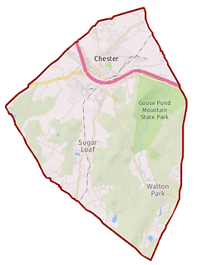
Town of Chester
Zoning Board of Appeals

1786 Kings Highway
Chester, NY 10918
(845) 469-7000 x338

Chairman: Gregg Feigelson

Members: Julie Bell
Dan Doellinger
Bob Favara
Walter Popailo
Alternate: Tom Atkin

Attorney: Robert Dickover
Secretary: Julie Tiller

Agenda
Nov.12, 2020 |  | 7:00 PM |  | Location: Zoom Teleconference  Information below
Time | Item
7:00 PM | Pledge of allegiance
 | Adoption of minutes |  | (as applicable)
 | Other business |  | (as applicable)
 | Item |  | Applicant / Address / Zone |  |  | Summary
 | Application Decision |  | Flower/Sandstrom  73 Dug Rd  S/B/L 24-2-10 AR-3 Zone |  |  | Area variance  For side yard
 | Public Hearing |  | Steve Germano  464 Pine Hill Rd  S/B/L 16-1-19.121 AR3 Zone |  |  | Area variance rear yard
 | Application Review |  | Yogesh & Aradhna Pal  15 Davis Hill Rd  S/B/L 7-1-51 AR3 Zone |  |  | Area variance
Join Zoom Meeting  https://us02web.zoom.us/j/83352677405  Meeting ID: 833 5267 7405  Passcode: 932702  One tap mobile  +19294362866,,83352677405#,,,,,,0#,,932702# US (New York)  +13126266799,,83352677405#,,,,,,0#,,932702# US (Chicago) |  |  |  |  | Dial by your location  +1 929 436 2866 US (New York)  +1 312 626 6799 US (Chicago)  +1 301 715 8592 US (Germantown)  +1 346 248 7799 US (Houston)  +1 669 900 6833 US (San Jose)  +1 253 215 8782 US (Tacoma)  Meeting ID: 833 5267 7405  Passcode: 932702  Find your local number: https://us02web.zoom.us/u/kcCc3yeXnd

